CS 255 Business Requirements Document Template

Complete this template by replacing the bracketed text with the relevant information.

This template lays out all the different sections that you need to complete for Project One. Each section has guiding questions to prompt your thinking. These questions are meant to guide your initial responses to each area. You are encouraged to go beyond these questions using what you have learned in your readings. You will need to continually reference the interview transcript as you work to make sure that you are addressing your client’s needs. There is no required length for the final document. Instead, the goal is to complete each section based on your client’s needs.

Tip: You should respond in a bulleted list for each section. This will make your thoughts easier to reference when you move into the design phase for Project Two. One starter bullet has been provided for you in each section, but you will need to add more.

System Components and Design

Purpose
What is the purpose of this project? Who is the client and what do they want their system to be able to do?
- New client – DriverPass: Liam (Owner/Boss) and Ian (IT Officer).
- The system aims to reduce DMV test failure rates by providing structured training, scheduling, practice tools, and optional on the road training.
- The purpose of this project is to design a secure, cloud-based system that supports registration, lesson scheduling, online learning, and administrative management.
- The system should allow customers and employees to access information from any device.
- Our consulting company aims to collect requirements, design the system, and deliver a solution that meets DriverPass’s training and operational needs.

System Background
What does DriverPass want the system to do? What is the problem they want to fix? What are the different components needed for this system?
- DriverPass needs a system that improves driving-test preparation through online practice tests/exams and optional on-road lessons.
- DriverPass wants to solve the issue of high failure rates on DMV driving tests caused by poor preparation and limited access to quality training.
- The system needs components for registration, scheduling, driver/vehicle assignment, package management, online course delivery, practice exam tracking, and reporting.
- The system must coordinate drivers and cars, ensuring each customer is assigned to an available driver and vehicle for every lesson.
- The system must track scheduling, driver availability, and car usage to prevent conflicts.
- The system must integrate with the DMV to receive updates on rules, regulations, policies, and test questions.
- Role-based access and security are required to ensure employees have appropriate and required permissions.
- The system must support both online and secretary-assisted registration, since customers may call or visit the office.

Objectives and Goals
What should this system be able to do when it is completed? What measurable tasks need to be included in the system design to achieve this?
- Customers can create accounts, log in, and reset passwords when needed.
- Customers can schedule, modify, and cancel driving lessons online.
- The secretary can register customers and manage appointments by phone or walk-in.
- Each customer lesson is assigned to an available driver and car.
- The system prevents double-booking of drivers or vehicles and allows authorized staff to manage driver schedules and car availability.
- The system provides online practice exams and tracks test status, scores, and completion history.
- Drivers can record lesson notes, including start time, end time, and comments.
- The system tracks all reservation activity, including who created, modified, or canceled appointments.
- The system supports role-based security and administrative controls for employees.
- The system should ensure each training package’s required number of driving hours is automatically reflected in the customer’s lesson schedule.
- The owner can enable or disable training packages.
- The system integrates with the DMV to receive updates and notify staff of changes.
- Users can download reports for offline review.
- The system runs on a cloud-based platform to minimize technical maintenance.

Requirements

Nonfunctional Requirements
In this section, you will detail the different nonfunctional requirements for the DriverPass system. You will need to think about the different things that the system needs to function properly.

Performance Requirements
What environments (web-based, application, etc.) does this system need to run in? How fast should the system run? How often should the system be updated?
- The system should run as a cloud-based web application accessible through both browsers and mobile devices and should load and process actions within a reasonable response time (within seconds).
- The system should support real-time scheduling updates to prevent double-booking and ensure accurate driver/car availability.
- The system updates DMV content whenever new rules, policies, or test questions are provided.
- The system should support simultaneous use by customers, drivers, and staff without performance degradation.

Platform Constraints
What platforms (Windows, Unix, etc.) should the system run on? Does the back end require any tools, such as a database, to support this application?
- The system should run on major operating systems such as Windows and macOS through a standard web browser.
- The back end should use a secure cloud database to store customer, driver, scheduling, and test data.
- The system should not require local installation; all functionality should be accessible online.
- The database must support relational data for reservations, users, packages, and test results.

Accuracy and Precision
How will you distinguish between different users? Is the input case-sensitive? When should the system inform the admin of a problem?
- The system should distinguish users by unique login IDs or email addresses.
- Input fields such as passwords should be case-sensitive.
- The system should validate required fields such as name, address, and credit card information.
- The system should notify administrators of errors such as failed updates, invalid data, or scheduling conflicts.
- The system should ensure pickup and drop-off locations match, as required during registration.
- The system should ensure accurate tracking of reservation changes, including timestamps and the identity of the user who made the change.

Adaptability
Can you make changes to the user (add/remove/modify) without changing code? How will the system adapt to platform updates? What type of access does the IT admin need?
- The system should allow administrators to add, remove, or update user accounts easily, without the need to change code.
- Since it is a cloud-based system, it should handle platform updates automatically to improve workflow and reduce maintenance requirements.
- The IT officer should have access to the tools necessary to keep operations running smoothly, i.e., system settings, logs, and security controls.
- The system should allow package disabling without affecting existing customer enrollments.
- The owner should have access to turn training packages on or off at his discretion, without the need for developer intervention.

Security
What is required for the user to log in? How can you secure the connection or the data exchange between the client and the server? What should happen to the account if there is a “brute force” hacking attempt? What happens if the user forgets their password?
- Users require valid login credentials to access the system, and all login activity should be handled securely.
- All data exchanged between the user and the system should be encrypted so sensitive information isn’t exposed during transmission.
- The system shall lock accounts temporarily after repeated failed login attempts to prevent brute-force attacks.
- If a user forgets their password, they should be able to reset it through a secure email verification process.
- All sensitive information, especially payment details, should be stored safely and handled according to industry security standards.
- Administrative actions such as account resets or access blocking must be logged for auditing.

Functional Requirements
Using the information from the scenario, think about the different functions the system needs to provide. Each of your bullets should start with “The system shall . . .” For example, one functional requirement might be, “The system shall validate user credentials when logging in.”
- The system shall validate user credentials when a customer or employee logs in.
- The system shall allow customers to create accounts and update their personal information.
- The system shall allow customers to schedule, modify, and cancel driving lessons.
- The system shall require customers to provide personal information including name, address, phone number, state, and payment details during registration.
- The system shall ensure pickup and drop-off locations match during registration.
- The system shall allow the secretary to register customers and manage appointments.
- The system shall assign each lesson to a specific driver and car.
- The system shall prevent scheduling conflicts for drivers and vehicles.
- The system shall allow authorized users to update driver schedules and car availability.
- The system shall track which driver and car were used for each lesson.
- The system shall allow drivers to enter lesson notes and record session times.
- The system shall track reservation activity, including who created, modified, or canceled a reservation.
- The system shall provide online practice exams and record scores and completion status.
- The system shall display test progress, including test name, time taken, score, and completion status.
- The system shall allow administrators to manage employee accounts and permissions.
- The system shall allow the owner to enable or disable training packages.
- The system shall integrate with the DMV to receive updates and notify users when changes occur.
- The system shall allow users to download reports in formats such as Excel.
- The system shall store customer payment information securely during registration.

User Interface
What are the needs of the interface? Who are the different users for this interface? What will each user need to be able to do through the interface? How will the user interact with the interface (mobile, browser, etc.)?
- The interface shall be web-based and accessible via desktops, laptops, tablets, and mobile devices.
- Customers shall use the interface to register, log in, schedule lessons, access online classes, take practice exams, and manage their training.
- Drivers should use the interface to view their assigned students, see which vehicle they’re using, and enter lesson notes after each session.
- Authorized employees shall be able to view driver schedules and car availability when managing appointments.
- The interface shall prevent users from selecting drivers or vehicles that are not available.
- The secretary should use the interface to update customer information and handling scheduling for phone or walk-in appointments.
- Administrators shall use the interface to manage employee accounts, permissions, and system settings.
- The interface shall display test progress, lesson history, driver comments, and package details so that users can easily track their training.
- The interface shall include forms for customer registration, contact information, and scheduling tools.

Assumptions
What things were not specifically addressed in your design above? What assumptions are you making in your design about the users or the technology they have?
- Customers are expected to have access to an internet-enabled device so they can use the system.
- Staff will manage driver and car availability, and both will have set schedules in the system.
- Cars are assumed to be available unless they’re specifically logged otherwise.
- The DMV will send updated rules, policies, and test questions in a timely manner.
- It is assumed that the DMV provides updates in a compatible digital format that the system can process.
- DriverPass employees will receive basic training so they can utilize the system properly.
- Cloud hosting will provide the storage, performance, and uptime needed for daily operations.
- Customers will input accurate personal and payment information during registration.

Limitations
Any system you build will naturally have limitations. What limitations do you see in your system design? What limitations do you have as far as resources, time, budget, or technology?
- The system cannot update or modify data while offline; offline access is strictly view-only.
- Driver and car assignments still need to be made manually by staff since automated optimization isn’t part of this release.
- Car maintenance tracking isn’t included in the initial version of the system.
- Customizing training packages (adding or removing) requires developer intervention and isn’t available in the first release.
- Budget and timeline constraints limit more advanced features such as mobile apps or automated driver assignment.
- DMV integration relies on external systems, so updates may only come as often as the DMV provides them.
- DMV integration may be limited to notifications rather than full automated synchronization, depending on DMV system capabilities.
- System performance depends on internet connectivity and the reliability of the cloud hosting provider.

Gantt Chart
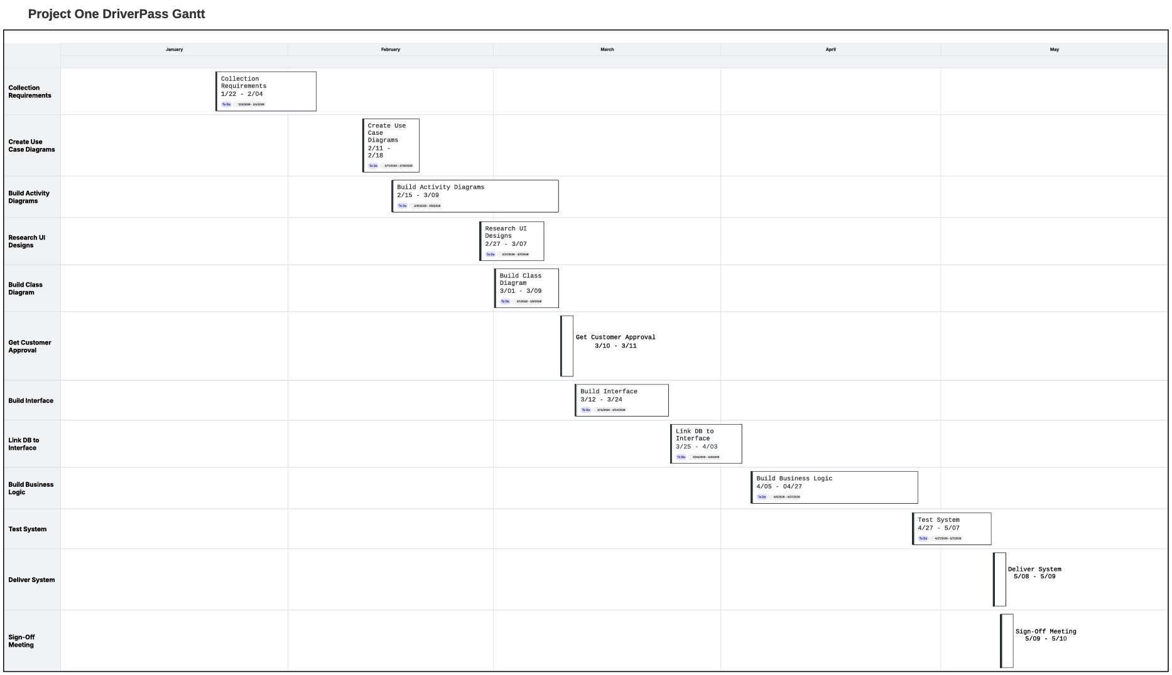
Please include a screenshot of the GANTT chart that you created with Lucidchart. Be sure to check that it meets the plan described by the characters in the interview.

